Capstone project

**Mobile Price Range Prediction**

**(Classification Analysis)**

**Presented By,**

**ANIKET ABHIT JADHAV**

**DATA SCIENCE TRAINEE (ALMABETTER)**

-----------------------------------------------------------***-----------------------------------------------------------

**Abstract:**

The mobile price range prediction project

aims to develop a machine learning model

that can accurately predict the price range of

mobile phones based on their features. The

project will involve data collection and

preprocessing, feature engineering, model

selection, and evaluation. The dataset will

consist of mobile phone features such as

brand, screen size, camera resolution,

battery capacity, and RAM. Various

machine learning algorithms such as logistic

regression, XGboost, and random forests

will be applied to the dataset to build the

prediction model. The accuracy of the model

will be evaluated using metrics such as

mean absolute error, mean squared error,

and R-squared. The project aims to help

customers make informed decisions when

purchasing mobile phones by providing

them with accurate price range predictions

based on phone features.

1. **Problem Statement**

In today's fiercely competitive mobile phone

market, understanding sales data and

identifying key factors that influence prices

is critical for companies to stay ahead of the

competition. To achieve this goal,

companies can leverage advanced analytics

techniques to identify the relationship

between various features of a mobile phone,

such as RAM, internal memory, camera

quality, processor speed, and battery life,

and their respective selling prices.

The primary objective of this analysis is not

to predict the exact selling price of a mobile

phone, but to identify a range that indicates

how high or low the price might be based on

its features. By using machine learning

algorithms, companies can train models on a

large dataset of mobile phones, including

their features and selling prices, to identify

patterns and correlations between different

variables.

Once the model is trained, it can be used to

predict the price range of a new mobile

phone based on its features. This

information can help manufacturers and

retailers in several ways, such as optimizing

pricing strategies, identifying product gaps,

and making informed decisions about which

features to prioritize in their product

offerings.

Overall, by analyzing the relationship

between mobile phone features and selling

prices, companies can gain valuable insights

that can help them stay competitive in the

market and better serve their customers'

needs.

1. **Introduction**

For a mobile price range prediction project,

the goal is to build a predictive model that

can help users estimate the price range of a

mobile phone based on its features and

specifications.

The model would take into account various

factors such as the brand, model, screen size,

camera quality, storage capacity, processor

type, and other features that affect the price

of a mobile phone. The model would

analyze these features and use machine

learning algorithms to predict the price

range of the mobile phone.

Similar to the surge pricing algorithm, the

mobile price range prediction model would

also be real-time and dynamic, adjusting the

predicted price range based on the latest

market trends and demand. The output of the

model would be a predicted price range for a

specific mobile phone model, which could

be communicated to the user.

The model would be trained on a dataset

containing various mobile phone models and

their corresponding prices, along with their

features and specifications. This dataset

would be used to train the model using

supervised learning algorithms, such as

linear regression, decision trees, or neural

networks, to make accurate predictions of

mobile phone price ranges.

Once the model is trained and validated, it

can be deployed as an application or

integrated into an existing mobile phone ecommerce

platform, allowing users to

estimate the price range of a mobile phone

before making a purchase decision.

**3. Types of Pricing**

In the context of mobile price range

prediction, companies may use static pricing

or dynamic pricing strategies to set their

prices.

Static pricing is a fixed pricing scheme that

remains the same regardless of fluctuations

in demand or supply. This pricing strategy is

often used in traditional retail settings where

the cost of goods sold is relatively stable.

Dynamic pricing, on the other hand, is a

flexible pricing strategy that adjusts prices in

real-time based on changes in supply and

demand. This strategy is becoming

increasingly popular in the mobile phone

market as companies seek to optimize

revenue and meet the needs of customers in

real-time.

Similar to surge pricing in the taxi industry,

dynamic pricing in mobile phone sales

adjusts prices based on fluctuations in

demand, supply, and other external factors

such as promotions, competitors' pricing,

and consumer behavior. By leveraging data

and analytics to track market trends,

companies can make strategic pricing

decisions and optimize revenue.

Overall, understanding the pros and cons of

static and dynamic pricing can help

companies develop effective pricing

strategies and stay competitive in a rapidly

evolving market.

**4. Mobile Price Drivers.**

In the context of mobile price range

prediction, there are several factors that can

contribute to price fluctuations. These

include:

Brand reputation: Established brands with a

strong reputation for quality and innovation

may command higher prices than lesserknown

brands.

Features and specifications: The features

and specifications of a mobile phone, such

as screen size, camera quality, processor

speed, battery life, and internal memory, can

all influence the selling price.

Target audience: The target audience for a

particular mobile phone can also impact its

price range. For example, a phone designed

for business professionals may be priced

differently than a phone marketed towards

students.

Market demand: Market demand for a

particular mobile phone can fluctuate based

on a variety of factors, such as consumer

preferences, seasonal trends, and global

events.

Competitor pricing: The pricing strategies of

competitors can also impact the price range

of a mobile phone. For example, if a

competitor lowers their prices, it may force

other companies to adjust their prices in

response.

Overall, understanding the various factors

that contribute to mobile phone prices can

help companies make informed decisions

about their product offerings and pricing

strategies, and ultimately better serve the

needs of their customers.

**5. How Mobile pricing works**

**1.Managing Mobile Price Surges**

In the context of mobile price range

prediction, sudden changes in demand can

also impact pricing. When demand for a

particular mobile phone model suddenly

increases, there may not be enough supply to

meet the demand. This can lead to a surge in

prices as consumers compete to purchase the

limited supply of phones.

Factors that can contribute to sudden

changes in demand for a mobile phone

model may include the release of a highly

anticipated new model, positive reviews

from influential sources, or a sudden change

in consumer preferences.

To mitigate the impact of sudden demand

surges, companies may implement strategies

such as limiting the number of phones sold

per customer or increasing production

capacity to meet the increased demand.

Understanding demand patterns and being

able to anticipate changes in consumer

preferences can help companies better

manage their pricing strategies and optimize

their supply chain operations.

**Dynamic Pricing in Mobile Sale**

In the context of mobile price range

prediction, when there is a surge in demand

for a particular mobile phone model, prices

may increase to ensure that supply is

available to those who are willing to pay a

premium price.

This dynamic pricing system is designed to

balance supply and demand in real-time, and

it allows companies to optimize revenue

while still meeting the needs of customers.

When prices are raised due to a surge in

demand, customers are typically notified via

marketing campaigns, advertisements, or

email newsletters.

Some customers may choose to pay the

premium price to ensure they get the phone

they want, while others may choose to wait

until prices come back down. Companies

may also choose to offer discounts or

incentives to encourage customers to

purchase at a higher price point, or they may

adjust production and supply to better meet

demand.

Overall, understanding the dynamics of

surge pricing and customer behavior can

help companies optimize their pricing

strategies, improve customer satisfaction,

and drive revenue growth.

**6. Steps involved:**

● **Exploratory Data Analysis**

After loading the dataset we

performed this method by comparing

our target variable that is

Surge Pricing Type with other

independent variables. This process

helped us figuring out various

aspects and relationships among the

target and the independent variables.

It gave us a better idea of which

feature behaves in which manner

compared to the target variable.

● **Null values Treatment**

Our dataset contains a large number

of null values which might tend to

disturb our accuracy hence we

dropped them at the beginning of our

project inorder to get a better result.

● **Encoding of categorical**

**columns**

We used One Hot Encoding to

produce binary integers of 0 and 1 to

encode our categorical features

because categorical features that are

in string format cannot be

understood by the machine and

needs to be converted to numerical

format.

● **Feature Selection**

In these steps we used algorithms

like ExtraTree classifier to check the

results of each feature i.e which

feature is more important compared

to our model and which is of less

importance.

Next we used Chi2 for categorical

features and ANOVA for numerical

features to select the best feature

which we will be using further in our

model.

● **Standardization of features**

Our main motive through this step

was to scale our data into a uniform

format that would allow us to utilize

the data in a better way while

performing fitting and applying

different algorithms to it.

The basic goal was to enforce a level

of consistency or uniformity to

certain practices or operations within

the selected environment.

● **Fitting different models**

For modelling we tried various

classification algorithms like:

**1. Logistic Regression**

**2. Random Forest Classifier**

**3. XGBoost classifier**

● **Tuning the hyperparameters**

**for better accuracy**

Tuning the hyperparameters of

respective algorithms is necessary for

getting better accuracy and to avoid

overfitting in case of tree based models

like Random Forest Classifier and

XGBoost classifier.

● **SHAP Values for features**

We have applied SHAP value plots

on the Random Forest model to

determine the features that were

most important while model building

and the features that didn’t put much

weight on the performance of our model.

**7.1. Algorithms:**

**1. Logistic Regression:**

Logistic Regression is actually a

classification algorithm that was

given the name regression due to the

fact that the mathematical

formulation is very similar to linear

regression.

The function used in Logistic

Regression is sigmoid function or the

logistic function given by:

f(x)= 1/1+e ^(-x)

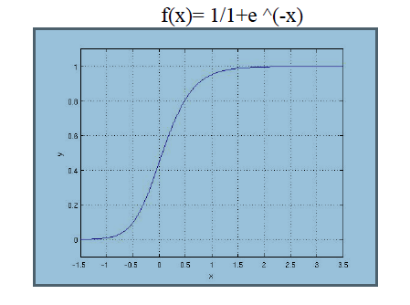

The optimization algorithm used is:

Maximum Log Likelihood. We mostly take

log likelihood in Logistic:

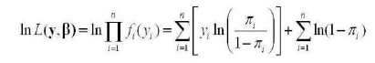

**2. Random Forest Classifier:**

Random Forest is a bagging type of

Decision Tree Algorithm that creates

a number of decision trees from a

randomly selected subset of the

training set, collects the labels from

these subsets and then averages the

final prediction depending on the

most number of times a label has

been predicted out of all.

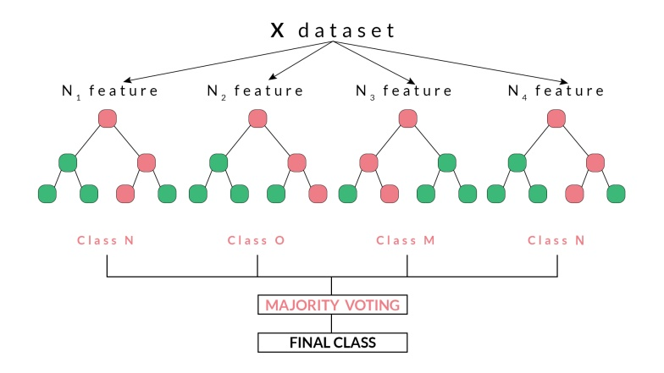

**3. XGBoost-**

To understand XGBoost we have to

know gradient boosting beforehand.

● **Gradient Boosting-**

Gradient boosted trees

consider the special case

where the simple model is a

decision tree

In this case, there are going

to be 2 kinds of parameters P:

the weights at each leaf, w,

and the number of leaves T in

each tree (so that in the above

example, T=3 and w=[2, 0.1,

-1]).

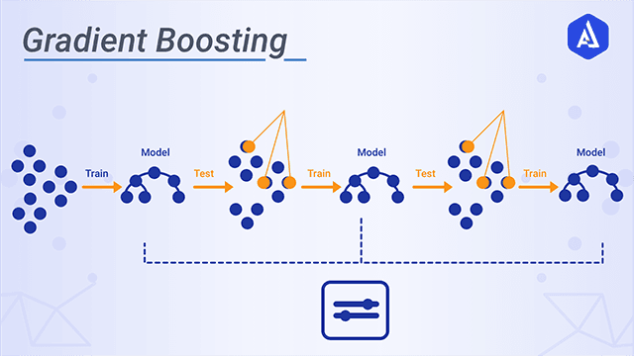

When building a decision tree,

a challenge is to decide how

to split a current leaf. For

instance, in the above image,

how could I add another layer

to the (age > 15) leaf? A

‘greedy’ way to do this is to

consider every possible split

on the remaining features (so,

gender and occupation), and

calculate the new loss for

each split; you could then

pick the tree which most

reduces your loss.

**XGBoost:**

is one of the fastest implementations

of gradient boosting. trees. It does

this by tackling one of the major

inefficiencies of gradient boosted

trees: considering the potential loss

for all possible splits to create a new

branch (especially if you consider

the case where there are thousands of

features, and therefore thousands of

possible splits). XGBoost tackles this

inefficiency by looking at the

distribution of features across all

data points in a leaf and using this

information to reduce the search

space of possible feature splits.

**7.2. Model performance:**

Model can be evaluated by various

metrics such as:

**1.Confusion Matrix**-

The confusion matrix is a table that

summarizes how successful the

classification modelis at predicting

examples belonging to various

classes. One axis of the confusion

matrix is the label that the model

predicted, and the other axis is the

actual label.

**2.Precision/Recall**-

Precision is the ratio of correct

positive predictions to the overall

number of positive predictions :

TP/TP+FP

Recall is the ratio of correct positive

predictions to the overall number of

positive examples in the set:

TP/FN+TP

**3.Accuracy**-

Accuracy is given by the number of

correctly classified examples divided

by the total number

of classified examples. In terms of

the confusion matrix, it is given by:

TP+TN/TP+TN+FP+FN

**4.Area under ROC**

**Curve(AUC)**-

ROC curves use a combination of the

true positive rate (the proportion of

positive examples predicted correctly,

defined exactly as recall) and false

positive rate (the proportion of

negative examples predicted

incorrectly) to build up a summary

picture of the classification

performance.

**7.3. Hyper parameter tuning:**

Hyperparameters are sets of information that

are used to control the way of learning an

algorithm. Their definitions impact

parameters of the models, seen as a way of

learning, change from the new

hyperparameters. This set of values affects

performance, stability and interpretation of a

model. Each algorithm requires a specific

hyperparameters grid that can be adjusted

according to the business problem.

Hyperparameters alter the way a model

learns to trigger this training algorithm after

parameters to generate outputs.

We used Grid Search CV, Randomized

Search CV and Bayesian Optimization for

hyperparameter tuning. This also results in

cross validation and in our case we divided

the dataset into different folds. The best

performance improvement among the three

was by Bayesian Optimization.

**1. Grid Search CV-**

Grid Search combines a selection of

hyperparameters established by the

scientist and runs through all of them

to evaluate the model’s performance.

Its advantage is that it is a simple

technique that will go through all the

programmed combinations. The

biggest disadvantage is that it

traverses a specific region of the

parameter space and cannot

understand which movement or

which region of the space is

important to optimize the model.

**2. Randomized Search CV-**

In Random Search, the hyperparameters

are chosen at random within a range

of values that it can assume. The

advantage of this method is that there

is a greater chance of finding regions

of the cost minimization space with

more suitable hyperparameters, since

the choice for each iteration is

random. The disadvantage of this

method is that the combination of

hyperparameters is beyond the

scientist’s control.

**3. Bayesian Optimization-**

Bayesian Hyperparameter

optimization is a very efficient and

interesting way to find good

hyperparameters. In this approach, in

naive interpretation way is to use a

support model to find the best

hyperparameters.A hyperparameter

optimization process based on a

probabilistic model, often Gaussian

Process, will be used to find data

from data observed in the later

distribution of the performance of

the given models or set of tested

hyperparameters.

As it is a Bayesian process at each

iteration, the distribution of the

model’s performance in relation to

the hyperparameters used is

evaluated and a new probability

distribution is generated. With this

distribution it is possible to make a

more appropriate choice of the set of

values that we will use so that our

algorithm learns in the best possible

way.

**8. Conclusion:**

Based on the evaluation metrics provided for

each model, it seems like the XGBoost

model performed better than the Logistic

Regression and Random Forest models. The

XGBoost model achieved a very high

accuracy score, precision, recall, and F1-

score for all classes, which indicates that the

model is performing very well on the

training set and able to generalize well to all

classes.

On the other hand, the Logistic Regression

model achieved a decent accuracy score and

precision for class 0, but its recall and F1-

score for class 0 were slightly lower

compared to the XGBoost model. Similarly,

the Random Forest model had moderate

performance, with accuracy, precision,

recall, and F1-score ranging from 0.63 to

0.92 depending on the class being predicted.

**References-**

1. MachineLearningMastery

2. GeeksforGeeks

3. Analytics Vidhya

4. Flowing Data

5. KDnuggets